FPST 2483 Hands-on Lab-Hydrostatics

Student Name: Liu Xinyu

Data Submitted: 2021/5/13

Data of the laboratory: 2021/4/28

Fire Protection and Safety Technology

Oklahoma State University

## Introduction and Objective

The objective of this laboratory unit is to illustrate the hydrostatic relationship between elevation and pressure and provide practice for the student in applying basic hydrostatic principles, in particular, Principle No. 3 and Principle No. 5.

## Procedure

1. Watch the lab activity at OSU
2. In the first part of this laboratory session, the standpipes located in the Fire Protection Laboratory Building is to be filled completely with water. The height of the standpipe is to be measured and pressure readings taken from the pressure gauges located the bottom of the standpipe. Measurements will need to be taken between gauges (centerline of the gauges)
3. Then, a smaller diameter pipe will be connected to a pressure gauge and a water supply source. A pressure reading will be taken at the pressure gauge. Then, valves will be opened at 2ft increments and the pressures taken at each increment. Measurements between the valves and the centerline of the gauge will need to be taken
4. Compared the predicted pressure and the actual pressure.
5. Check if they comply with each other

## Results and Calculations

#### Principle 3

To apply principle 3, two trails are carried out in a regular pipe and a smaller pipe. If there is not significant difference between the predicted pressure and the measured pressure, then it can be concluded that the principle 3 has been verified.

The recorded pressure value should be used to calculated the predicted pressure of the same valve through the formula below:

P=wh (Equation 1.1)

Here P is the predicted pressure in Mpa,

w is the gravity accelerator of water in m2/s, and

h is the height of the free surface water in m

For example when the height is 11.97ftthe corresponding predicted pressure should be

P=wh

P=0.433(psi/ft)(11.97ft)=5.18psi

And the pressure measured in the last valve should be added up to get a 5.47 psi, which is the value in the table 1,1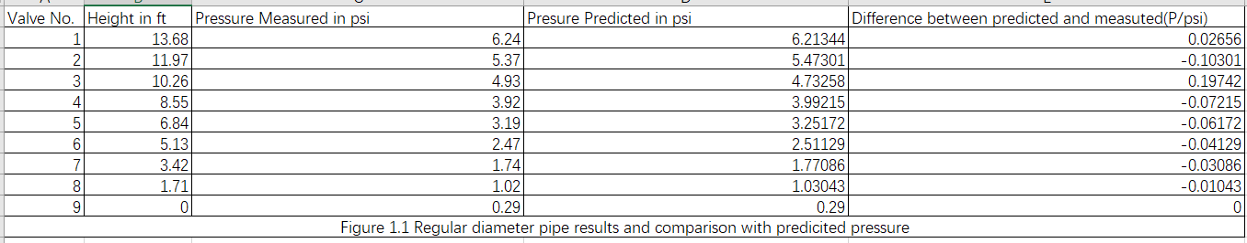

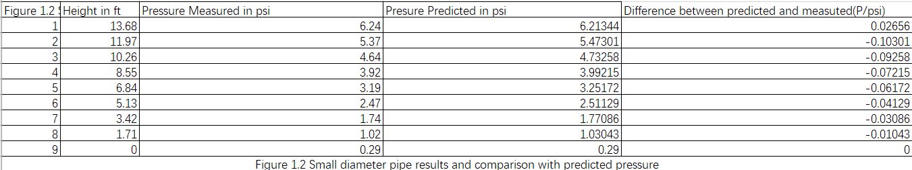

No significant difference in the two pipes has been seen and thus the principle 3 are verified.

#### Principle 5

In order to apply 5, pressure in different size of pipes can be measured and compared together to see whether the shape and volume of liquid has no influence on the pressure. No calculation are needed in this table and thus no formula will be given here, 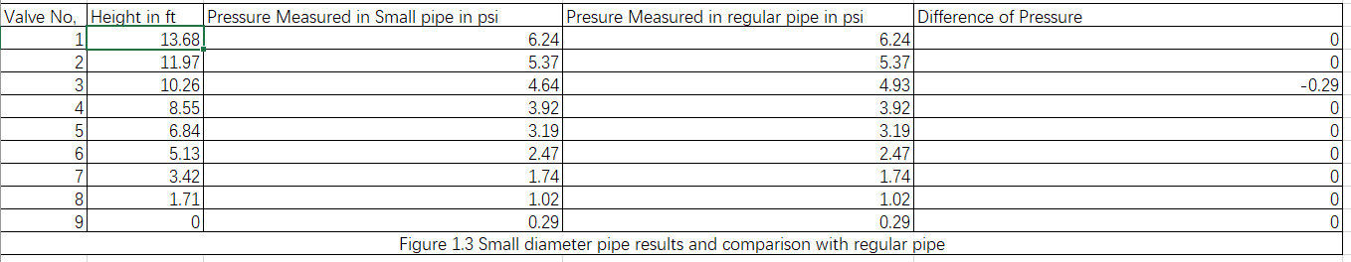

It can be concluded from the table that there is no significant difference between the pressure of the regulat and small pipe, thus the principle 5 is vertified.

## Summary and Conclusion

Form the table1.1 and 1.2, a simple conclusion could be made that there is no significant difference between the measured pressure and the predicted pressure. Thus, in this experiment, the pressure of free surface is directly proportional to the depth of the liquid. And this is what the 3rd principle of hydrostatics indicates.

From the table 1.3, it can be general concluded that there is no significant difference between the measured pressure for the regular pipe and the pipe of smaller pipe diameter. As a result, it can be concluded that the shape or volume of the container has no bearing on the pressure created by the liquid. This is what the 5th principle of hydrostatics wants to tell us.